RESOLUTION NO.__________

RE: CERTIFICATE OF APPROPRIATENESS UNDER THE
PROVISIONS OF THE ACT OF THE PENNSYLVANIA
LEGISLATURE 1961, JUNE 13, P.L. 282 (53
SECTION 8004) AND BETHLEHEM ORDINANCE NO.
3952 AS AMENDED.

WHEREAS, it is proposed to install two bronze signs to the left of the entrance door at 79 West Market St.

NOW, THEREFORE, BE IT RESOLVED by the Council of the City of Bethlehem that a Certificate of Appropriateness is hereby granted for the proposal.

Sponsored by: (s)

(s)

ADOPTED BY COUNCIL THIS DAY OF

(s)
President of Council

ATTEST:

(s)
City Clerk

HISTORICAL & ARCHITECTURAL REVIEW BOARD

The applicant proposes to install two bronze signs to the left of the entrance door at 79 W. Market St.
APPLICATION #1:

CRB Properties
1348 Hamilton St.
Allentown, PA 18102

OWNER:

__________________________________________________________________

The Board upon motion by Connie Glagola and seconded by Nancy Shelly adopted the proposal that City Council issue a Certificate of Appropriateness for the following:

- Two bronze signs are to be mounted above one another.

- The signs will match the size and material of the existing sign mounted on
the right side of the entrance door.

3. Existing White painted sign located to the right of the existing bronze sign will be
removed from the building.

4. Signs are to be mounted so that the bottom sign will be in alignment with the
existing bronze sign.

5. The motion was unanimously approved.

__________________________________________________________________________

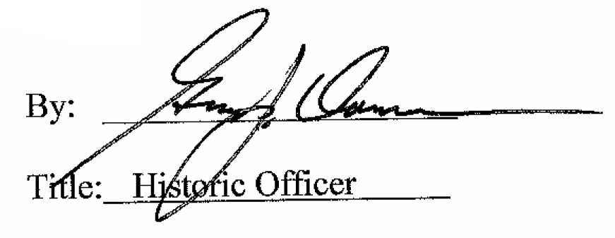

Date of Meeting: Octrober 7, 2015

